# Informações do estudo

Referência: Keblouti - uncoated insert

Grandeza: Força

Tipo: Fy

Material: AISI 52100

Ferramenta: CT5015 uncoated insert

Número de experimentos: 27

Observações:  
Universal lathe SN 40C type  
Workpiece: round bars66 mm of diameter and 380 mm cutting length.  
Dynamometer: KISTLER Type 9257A  
Roughnessmeter: Surftest 201 Mitutoyo

# Unidades

Velocidade: m/min

Avanço: mm/rev

Profundidade de corte: mm

Força: N

# Dados de teste

|  |  |  |  |
| --- | --- | --- | --- |
| Força | n | f | a |
| 88.44 | 200.0 | 0.08 | 0.15 |
| 186.04 | 250.0 | 0.16 | 0.45 |
| 132.53 | 150.0 | 0.16 | 0.15 |
| 150.93 | 200.0 | 0.16 | 0.3 |
| 98.5 | 150.0 | 0.08 | 0.15 |
| 124.58 | 250.0 | 0.08 | 0.45 |

# Dados de treino

|  |  |  |  |
| --- | --- | --- | --- |
| Força | n | f | a |
| 176.5 | 200.0 | 0.16 | 0.45 |
| 128.57 | 150.0 | 0.08 | 0.3 |
| 160.59 | 150.0 | 0.12 | 0.3 |
| 162.28 | 250.0 | 0.12 | 0.45 |
| 144.21 | 200.0 | 0.12 | 0.3 |
| 79.65 | 250.0 | 0.16 | 0.3 |
| 119.56 | 150.0 | 0.12 | 0.15 |
| 244.63 | 150.0 | 0.16 | 0.45 |
| 195.12 | 150.0 | 0.12 | 0.45 |
| 108.76 | 200.0 | 0.12 | 0.15 |
| 102.04 | 200.0 | 0.16 | 0.15 |
| 95.14 | 250.0 | 0.08 | 0.15 |
| 155.9 | 200.0 | 0.12 | 0.45 |
| 117.12 | 250.0 | 0.12 | 0.3 |
| 107.01 | 250.0 | 0.08 | 0.3 |
| 175.13 | 150.0 | 0.16 | 0.3 |
| 92.78 | 250.0 | 0.16 | 0.15 |
| 77.47 | 250.0 | 0.12 | 0.15 |
| 165.04 | 150.0 | 0.08 | 0.45 |
| 142.98 | 200.0 | 0.08 | 0.45 |
| 126.06 | 200.0 | 0.08 | 0.3 |

# RN

Número de neurônios: 29

Taxa de aprendizado: 1.000000e-03

Número de épocas: 469

2° camada: False

Função de ativação: relu

# Erros

**Dados de teste**

* Erro relativo médio: 10.5
* Coeficiente de correlação: 0.98
* Coeficiente de determinação: 0.96
* MSE: 256.65
* RMSE: 16.02

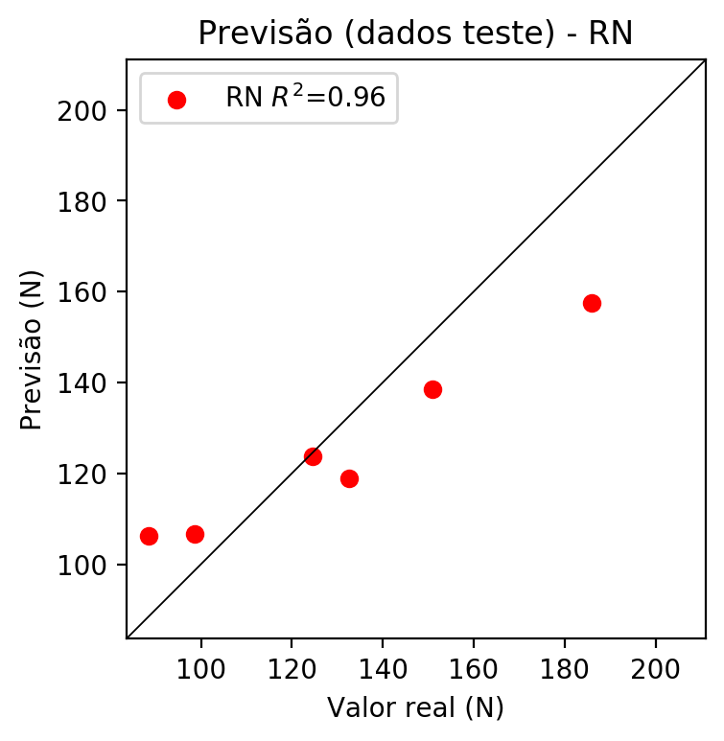

**Dados de treino**

* Erro relativo médio: 6.41
* Coeficiente de correlação: 0.97
* Coeficiente de determinação: 0.93
* MSE: 109.33
* RMSE: 10.46

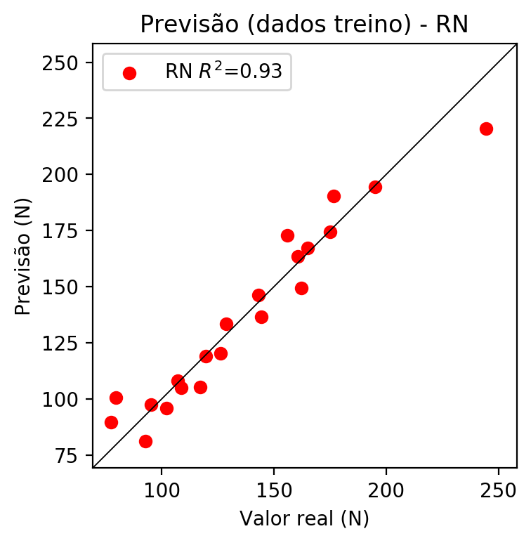

# Pesos

Pesos - camada oculta 1

[[ 0.12967783 0.02486513 -0.15595356 0.25425333 0.09669694 -0.09096174  
 -0.34316456 0.3516004 0.15286063 -0.23326418 -0.24554236 0.12288467  
 0.02956469 0.4289539 -0.05695449 0.09691648 -0.27170178 0.18625721  
 -0.21821648 0.15327534 0.17889641 0.14406422 -0.15975668 0.07061838  
 0.23709661 -0.16488118 0.24001797 -0.24185485 0.17239496]  
 [-0.04502702 -0.06472848 -0.6104559 -0.7296077 -0.01048355 -0.044  
 0.1214275 0.23210287 0.33489466 0.06591301 -0.3521797 0.01128651  
 0.05762483 0.09109525 0.35670593 0.37269014 0.12134252 0.11560901  
 -0.29909804 0.35017985 0.5596992 0.01386122 0.22612512 0.02316676  
 0.13130675 -0.20040508 -0.0874972 0.30769038 -0.04533473]  
 [-0.32366836 -0.31281605 0.27035484 -0.30901816 -0.2804119 0.00169944  
 0.5022663 -0.37427357 -0.14891812 0.3294009 -0.47098246 -0.1391847  
 -0.02088467 0.10884818 -0.12195389 -0.39068723 0.34777793 -0.36145884  
 0.06817232 0.4768628 0.16648379 -0.01272494 0.2636514 -0.3507051  
 -0.49572647 -0.15277421 -0.1382495 0.53874993 0.09102432]]

Bias - camada oculta

[-0.10013439 -0.06502038 -0.0715723 0.04511101 -0.10089696 -0.11475831  
 0.24239472 0.13507156 -0.03897027 0.20103821 -0.1567744 -0.13616829  
 -0.10483772 0.2766723 -0.18969652 0.13804817 0.19071424 0.15224352  
 -0.13419394 -0.0735207 -0.10926882 -0.14900257 -0.07973578 -0.11263163  
 0.17789316 -0.1337097 -0.16437554 0.16939142 -0.15261681]

Pesos - camada saída

[[ 0.17021102 0.00951851 -0.22246432 -0.16960183 0.13531369 -0.13468352  
 0.19674282 -0.16001165 -0.351713 0.44827715 -0.17600559 0.17585473  
 0.05746001 -0.49238512 0.01485604 -0.31030113 0.45275182 -0.31719503  
 -0.2554389 0.17664458 0.2362098 0.19131348 0.09984583 0.13982792  
 -0.25596645 -0.17408068 0.30341968 0.3845874 0.2264787 ]]

# Iterações

|  |  |  |  |  |  |  |
| --- | --- | --- | --- | --- | --- | --- |
| Média | Desvio | n | ln | 2° camada | Função | Épocas |
| -0.4144 | 0.4257 | 10 | 0.1 | False | relu | 38 |
| -0.3873 | 0.4184 | 17 | 0.1 | True | relu | 716 |
| -0.331 | 0.4298 | 7 | 0.01 | True | tanh | 130 |
| -0.5758 | 0.6739 | 19 | 0.001 | False | tanh | 282 |
| -0.2853 | 0.3882 | 29 | 0.001 | False | relu | 469 |
| -0.5711 | 0.5988 | 88 | 0.1 | False | tanh | 926 |
| -0.3211 | 0.2692 | 95 | 0.0001 | True | relu | 984 |
| -0.4753 | 0.4133 | 10 | 0.01 | True | tanh | 865 |
| -0.7392 | 0.7652 | 58 | 0.001 | True | relu | 8 |
| -0.3158 | 0.3249 | 9 | 0.01 | False | tanh | 514 |
| -0.2903 | 0.2425 | 73 | 0.0001 | True | relu | 729 |
| -0.3754 | 0.3805 | 22 | 0.001 | True | relu | 543 |
| -0.3951 | 0.2895 | 25 | 0.1 | True | relu | 562 |
| -0.286 | 0.3206 | 53 | 0.001 | False | relu | 498 |
| -0.4035 | 0.2726 | 83 | 0.01 | True | relu | 337 |
| -0.5028 | 0.4558 | 99 | 0.01 | False | tanh | 16 |
| -0.4566 | 0.3995 | 23 | 0.01 | False | relu | 472 |
| -0.5158 | 0.4516 | 24 | 0.001 | True | relu | 778 |
| -0.4977 | 0.4902 | 58 | 0.01 | True | tanh | 382 |
| -0.509 | 0.292 | 35 | 0.1 | False | tanh | 596 |

# RL

# Coeficientes

[ 0. -0.48441638 0.24183404 0.6906155 ]

# Erros

**Dados de teste**

* Erro relativo médio: 7.89
* Coeficiente de correlação: 0.94
* Coeficiente de determinação: 0.88
* MSE: 202.47
* RMSE: 14.23

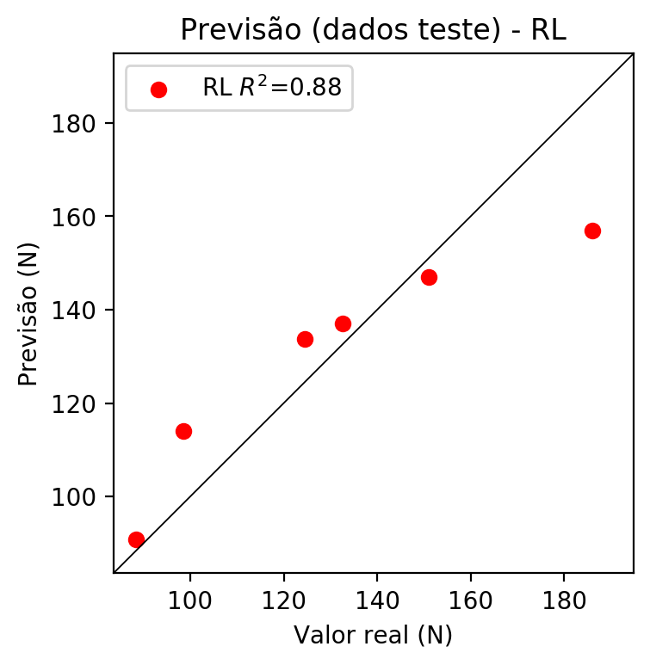

**Dados de treino**

* Erro relativo médio: 9.81
* Coeficiente de correlação: 0.91
* Coeficiente de determinação: 0.83
* MSE: 288.3
* RMSE: 16.98

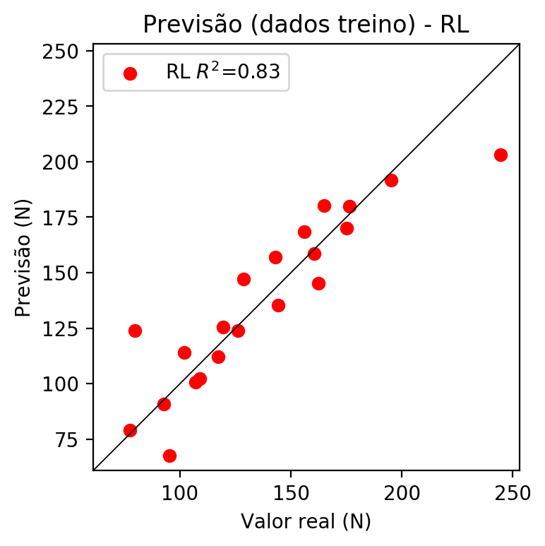

# RP2

# Coeficientes

[ 0. -0.48547293 0.22363356 0.68691759 0.06391047 -0.29716355  
 -0.10010132 -0.09382837 0.08253326 0.09611454]

# Erros

**Dados de teste**

* Erro relativo médio: 10.51
* Coeficiente de correlação: 0.76
* Coeficiente de determinação: 0.58
* MSE: 488.21
* RMSE: 22.1

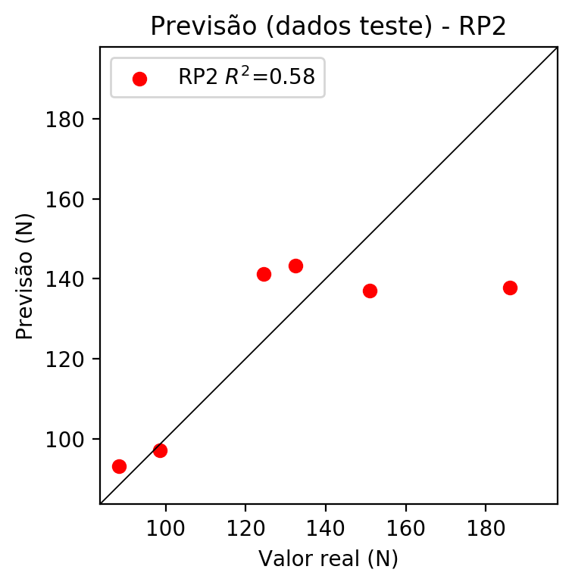

**Dados de treino**

* Erro relativo médio: 6.98
* Coeficiente de correlação: 0.97
* Coeficiente de determinação: 0.94
* MSE: 106.11
* RMSE: 10.3

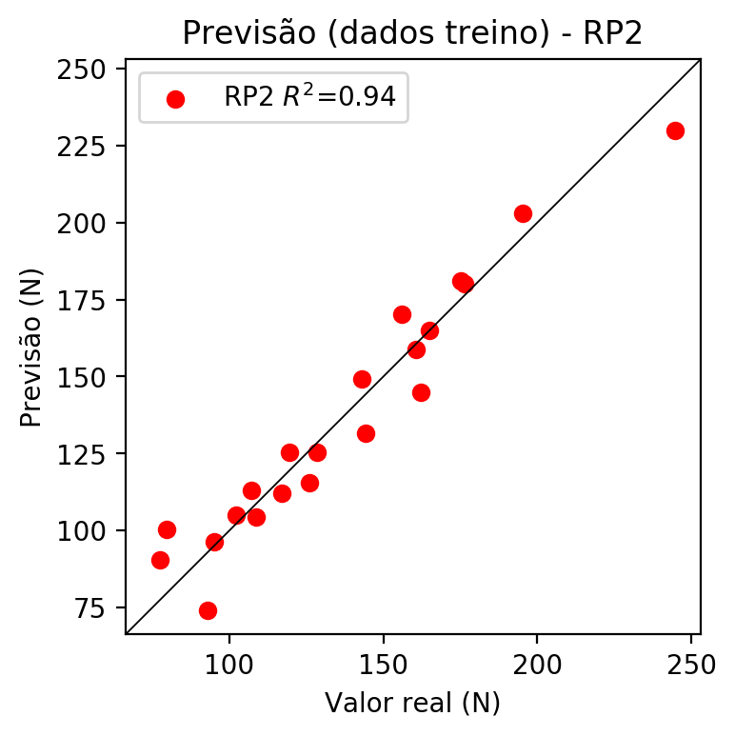

# RP3

# Coeficientes

[ 0. -0.16938018 -0.00946227 0.18179179 0.07321332 -0.27651047  
 -0.08478213 -0.0831606 0.12383942 0.14672355 -0.24466027 0.08959102  
 0.167099 -0.03706169 -0.08728113 0.11508811 -0.01366772 -0.01432572  
 0.12239003 0.26258814]

# Erros

**Dados de teste**

* Erro relativo médio: 13.85
* Coeficiente de correlação: 0.71
* Coeficiente de determinação: 0.51
* MSE: 543.43
* RMSE: 23.31

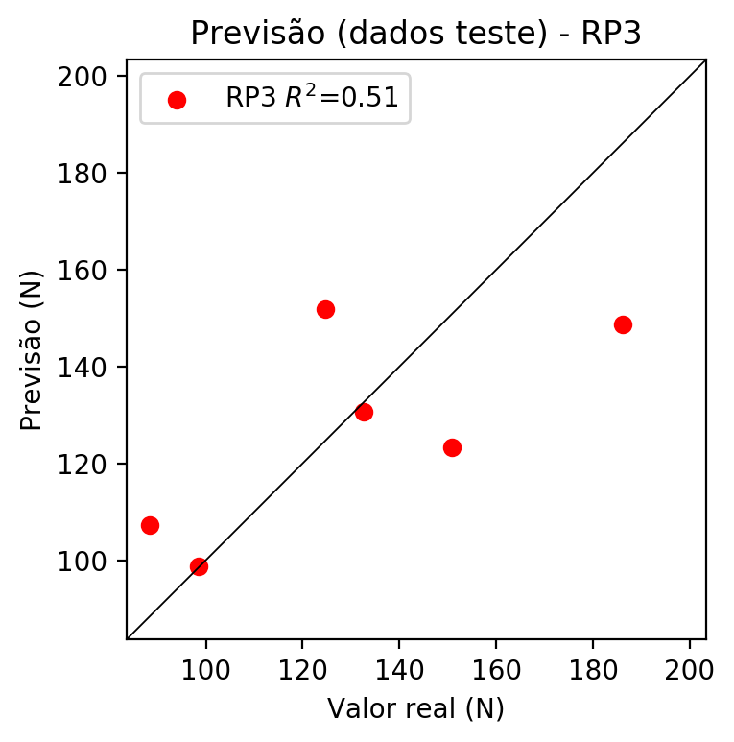

**Dados de treino**

* Erro relativo médio: 5.33
* Coeficiente de correlação: 0.98
* Coeficiente de determinação: 0.97
* MSE: 54.05
* RMSE: 7.35

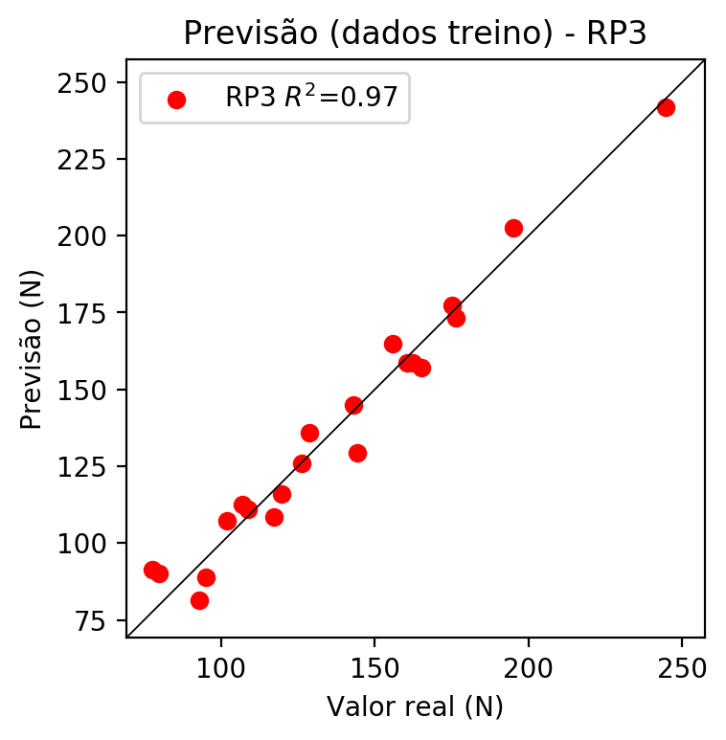

# RP4

# Coeficientes

[-3.05311332e-16 -1.47011605e-01 1.05385338e-02 1.59423213e-01  
 -3.01370701e-02 -6.20539606e-02 7.76513983e-03 -9.33766615e-02  
 8.25119560e-02 -6.68587102e-02 -2.12350096e-01 4.68542676e-02  
 2.38793160e-01 -1.08755850e-01 -3.45100369e-01 4.33939453e-02  
 1.52223265e-02 -1.57714048e-01 -1.35429208e-01 2.30277974e-01  
 -4.35313235e-02 -8.96334987e-02 1.12163131e-02 3.93137537e-03  
 -1.35675379e-01 1.39884232e-01 -8.96334987e-02 2.37731103e-02  
 1.35675379e-01 1.12163131e-02 -1.34877400e-01 1.19183937e-01  
 3.76925930e-01 1.19183937e-01 -9.65736925e-02]

# Erros

**Dados de teste**

* Erro relativo médio: 46.2
* Coeficiente de correlação: -0.63
* Coeficiente de determinação: 0.4
* MSE: 3459.5
* RMSE: 58.82

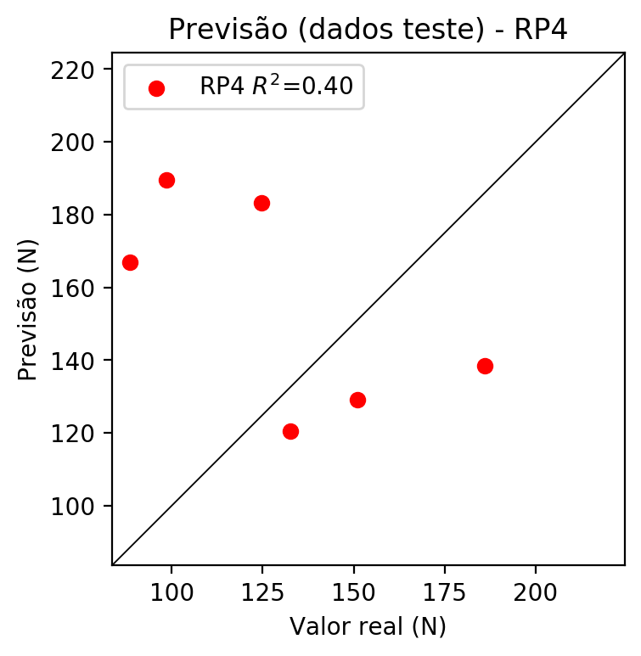

**Dados de treino**

* Erro relativo médio: 0.0
* Coeficiente de correlação: 1.0
* Coeficiente de determinação: 1.0
* MSE: 0.0
* RMSE: 0.0

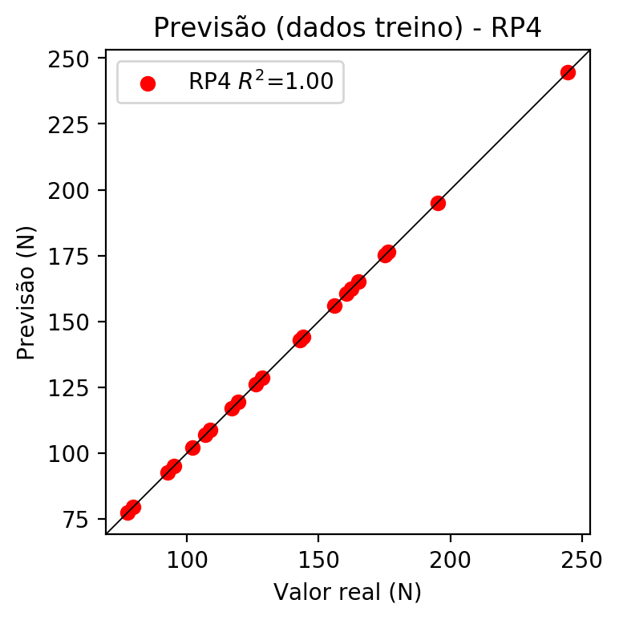

# Geral

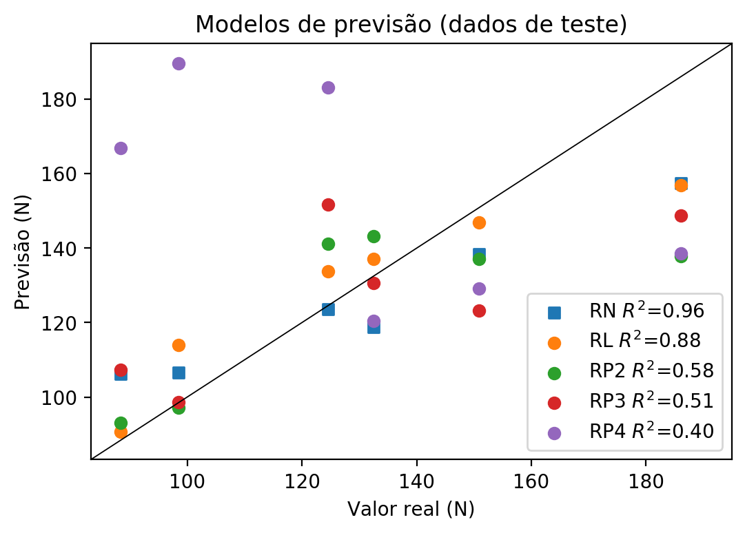

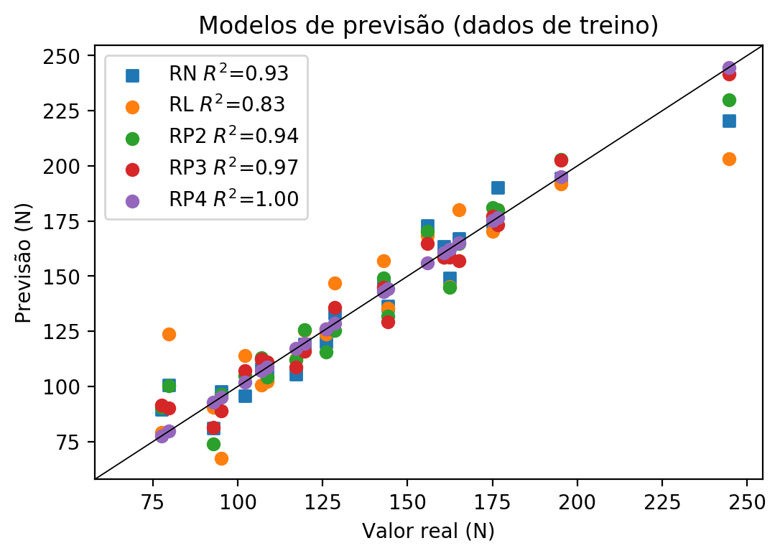

**Dados de teste**

|  |  |  |  |  |  |  |  |  |  |  |
| --- | --- | --- | --- | --- | --- | --- | --- | --- | --- | --- |
| Valor real | RN Previsto | RN Erro (%) | RL Previsto | RL Erro (%) | RP2 Previsto | RP2 Erro (%) | RP3 Previsto | RP3 Erro (%) | RP4 Previsto | RP4 Erro (%) |
| 88.44 | 106.2 | 20.08 | 90.74 | 2.6 | 93.01 | 5.17 | 107.28 | 21.3 | 166.81 | 88.61 |
| 186.04 | 157.51 | 15.34 | 156.86 | 15.68 | 137.8 | 25.93 | 148.69 | 20.08 | 138.54 | 25.53 |
| 132.53 | 118.85 | 10.32 | 137.11 | 3.46 | 143.22 | 8.07 | 130.66 | 1.41 | 120.51 | 9.07 |
| 150.93 | 138.41 | 8.3 | 146.99 | 2.61 | 137.06 | 9.19 | 123.26 | 18.33 | 129.18 | 14.41 |
| 98.5 | 106.61 | 8.23 | 113.94 | 15.68 | 97.08 | 1.44 | 98.62 | 0.12 | 189.6 | 92.49 |
| 124.58 | 123.67 | 0.73 | 133.7 | 7.32 | 141.09 | 13.25 | 151.81 | 21.86 | 183.25 | 47.09 |

**Dados de treino**

|  |  |  |  |  |  |  |  |  |  |  |
| --- | --- | --- | --- | --- | --- | --- | --- | --- | --- | --- |
| Valor real | RN Previsto | RN Erro (%) | RL Previsto | RL Erro (%) | RP2 Previsto | RP2 Erro (%) | RP3 Previsto | RP3 Erro (%) | RP4 Previsto | RP4 Erro (%) |
| 176.5 | 190.27 | 7.8 | 180.07 | 2.02 | 180.25 | 2.12 | 173.19 | 1.88 | 176.5 | 0.0 |
| 128.57 | 133.32 | 3.69 | 147.02 | 14.35 | 125.46 | 2.42 | 135.76 | 5.59 | 128.57 | 0.0 |
| 160.59 | 163.59 | 1.87 | 158.61 | 1.23 | 158.68 | 1.19 | 158.71 | 1.17 | 160.59 | 0.0 |
| 162.28 | 149.28 | 8.01 | 145.28 | 10.48 | 144.85 | 10.74 | 158.59 | 2.27 | 162.28 | 0.0 |
| 144.21 | 136.52 | 5.33 | 135.4 | 6.11 | 131.75 | 8.64 | 129.45 | 10.24 | 144.21 | 0.0 |
| 79.65 | 100.7 | 26.43 | 123.78 | 55.4 | 100.38 | 26.03 | 90.15 | 13.18 | 79.65 | 0.0 |
| 119.56 | 119.11 | 0.38 | 125.53 | 4.99 | 125.55 | 5.01 | 115.87 | 3.09 | 119.56 | 0.0 |
| 244.63 | 220.48 | 9.87 | 203.27 | 16.91 | 230.05 | 5.96 | 241.65 | 1.22 | 244.63 | 0.0 |
| 195.12 | 194.31 | 0.42 | 191.69 | 1.76 | 202.88 | 3.98 | 202.51 | 3.79 | 195.12 | 0.0 |
| 108.76 | 104.93 | 3.52 | 102.32 | 5.92 | 104.38 | 4.03 | 111.02 | 2.08 | 108.76 | 0.0 |
| 102.04 | 95.9 | 6.02 | 113.91 | 11.63 | 104.94 | 2.84 | 107.16 | 5.02 | 102.04 | 0.0 |
| 95.14 | 97.57 | 2.55 | 67.53 | 29.02 | 96.31 | 1.23 | 88.85 | 6.61 | 95.14 | 0.0 |
| 155.9 | 172.91 | 10.91 | 168.48 | 8.07 | 170.19 | 9.17 | 164.77 | 5.69 | 155.9 | 0.0 |
| 117.12 | 105.4 | 10.01 | 112.2 | 4.2 | 112.17 | 4.23 | 108.62 | 7.26 | 117.12 | 0.0 |
| 107.01 | 107.97 | 0.9 | 100.61 | 5.98 | 113.17 | 5.76 | 112.39 | 5.03 | 107.01 | 0.0 |
| 175.13 | 174.46 | 0.38 | 170.19 | 2.82 | 181.1 | 3.41 | 177.2 | 1.18 | 175.13 | 0.0 |
| 92.78 | 81.25 | 12.43 | 90.7 | 2.24 | 74.02 | 20.22 | 81.37 | 12.3 | 92.78 | 0.0 |
| 77.47 | 89.71 | 15.8 | 79.12 | 2.13 | 90.56 | 16.9 | 91.47 | 18.07 | 77.47 | 0.0 |
| 165.04 | 167.22 | 1.32 | 180.1 | 9.13 | 164.91 | 0.08 | 156.94 | 4.91 | 165.04 | 0.0 |
| 142.98 | 146.18 | 2.24 | 156.9 | 9.74 | 149.32 | 4.43 | 144.79 | 1.27 | 142.98 | 0.0 |
| 126.06 | 120.12 | 4.71 | 123.82 | 1.78 | 115.63 | 8.27 | 126.06 | 0.0 | 126.06 | 0.0 |